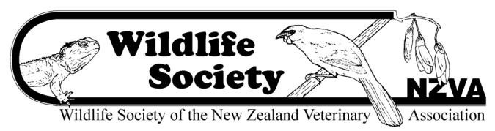

Marion Cunningham Memorial Fund

Criteria
Marion Cunningham provided a bequest to the Wildlife Society of the New Zealand Veterinary Association (NZVA) with the wish that it be used to promote work on the preservation of endangered species of wildlife.

A total of $2,000 is available for 2022 applications.

The successful applicant will also receive registration to the annual NZVA Wildlife Conference, provided they make a presentation on their use of the fund.

Criteria for granting each award

- The project must be compatible with one or more of the major objectives of the Wildlife Society, which are:
  - To enhance veterinary contributions to the welfare and management of New Zealand's wildlife and to support research in this field.
  - To promote communication among both veterinarians and non-veterinarians with expertise in wildlife management and research.
  - To provide the NZVA, when possible, with technical and other information on wildlife.
  - To encourage conservation, especially by veterinary contributions to the management of threatened species.
- The project must be practicable and relevant to current wildlife concerns.
- The information provided must indicate that the applicant will be able to carry out the work competently and satisfactorily document the results.
- Applications must be approved by the supervisor of the project, who will be responsible for ensuring that the conditions of the grant are met.
- It is the responsibility of grant holders to ensure they have the appropriate permits approved by regulatory bodies such as the Department of Conservation and relevant animal ethics committees.
- All grant monies must be spent within New Zealand, even if the study has an overseas component.
- Each grant is given for a one-year period and cannot be carried forward to a subsequent year.
- If the grant cannot be spent on the approved project, the Wildlife Society must be notified as soon as possible, and unspent funds returned.
- The recipient will submit a project summary and financial accounting on the use of the funds within 12 months of receiving the grant.
- The recipient will submit a report suitable for publication in Kokako (the Wildlife Society bulletin) within 15 months of receiving the grant.
- The recipient will receive a complementary three-day registration to the NZVA Wildlife Conference (excluding workshops and field trips) provided the recipient provides a presentation on their use of the fund.
- The Wildlife Society would like recipients of the grant to publish their findings in a scientific journal, if possible. All publications arising from the project should acknowledge the Marion Cunningham Memorial Fund.
- Applications open on 1 September 2022 and close on 31 October 2022. Only applications received by midnight on the due date will be considered.

To apply for the Marion Cunningham Memorial Fund, please complete the application form on the NZVA website and email it to wildlife@vets.org.nz.

