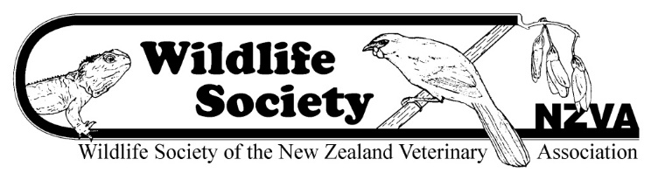

Marion Cunningham Memorial Fund

Application
Please refer to the application criteria on the NZVA website for more information.

Applications open on 1 September 2022 and close on 31 October 2022.

Applications should be typed.

Please email your application to wildlife@vets.org.nz with ‘Marion Cunningham Memorial Fund Application 2022’ in the subject line.

Student’s name:
ID number:
Institution/organisation:
Degree enrolled:
Email address:
Supervisor:
Supervisor’s email address:
Title of research project:
Brief outline of research project including scientific content (attach maximum of one page)
Budget details:
Amount requested: $
Other sources of funding:
Applicant’s signature:
Date:
Supervisor’s signature:
Date:

